GPU Computing Course Project Report
Seyed Hossein Mohammadi

Part 1 – introduction
- System in question (retrieved using the device_info.cpp):
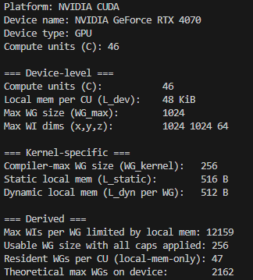

- The problem description:
2D Convolution/Filter (i.e. Discrete plane wise cross-correlation)
I’m assuming that most are familiar with this operation, but just in case, I will explain the jests.
We have a 3d tensor (i.e. image) which we want to apply a filter to, or in other words, compute the multiplied and summed patches of data with some predetermined kernel. The kernel is dragged over the data and a number is calculated per patch of the image. A stride could be applied too.
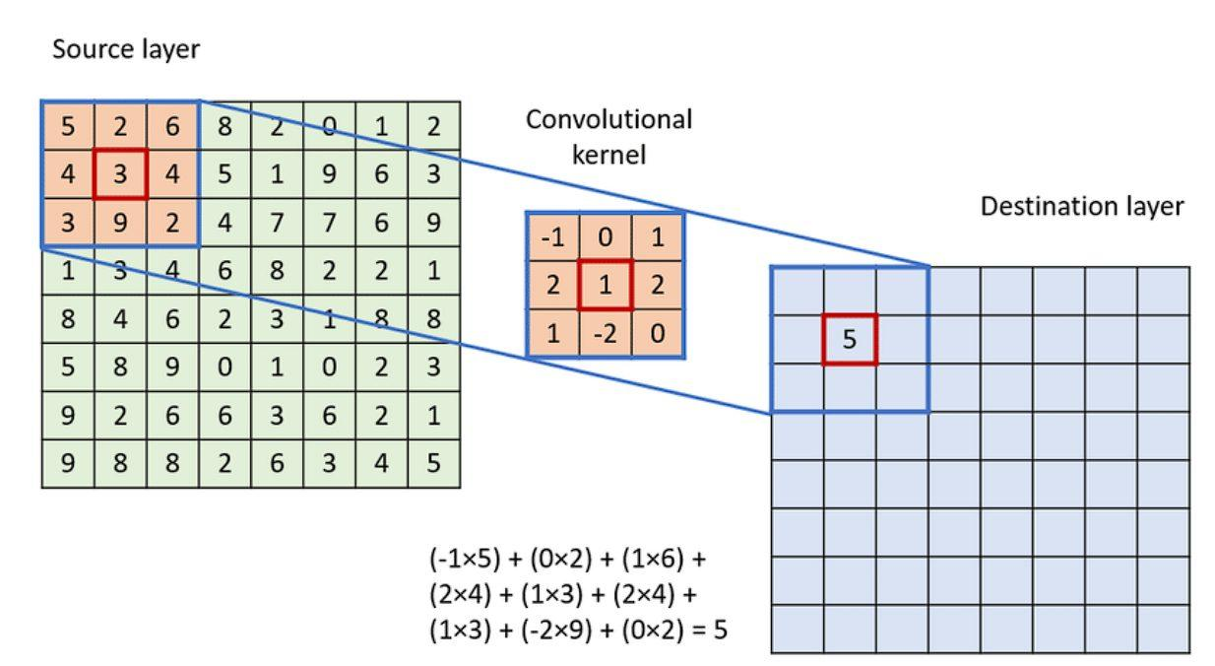
The output will be a 2D data per kernel used, with the size relating to the stride and how large the kernel is. Each kernel is of some width, height and also a depth equal to the channel counts of the data (the depth of the input).
- Code progress summary:
NOTE: Details on why some decisions were made are in part 2.
Multiple, highly modular, C++ code we written for this problem (on top of other codes for system information, etc.) with the following features:
- utilities.hpp:
PNG image reading/writing with STB library
Loading/generating batch data
Convolution filter loading from files
Input data generation and batch processing
Command-line argument parsing
Passing args and running of the main code body

- conv_2d_gpu.hpp:
OpenCL context/device initialization (and select NVIDIA GPUs)
Dynamic kernel loading from files
Work group size optimization
Local memory configuration

- conv_2d_sequential.cpp & function.cpp:
CPU implementation of conv2d, simulating multiple batches of data

- conv_2d_gpu.cpp:
gets the data, configures the opencl, schedules upload, download and kernel exec. The code could be ran without local mem, full-duplex or pinned-memory via #define.
- XXXXX

Part 2 – Experiments
We have multiple things that we can tackle. First, we have a data of size W*H*C, with C being the number of channels. We call this data, a batch, as with increasing C, we essentially could concatenate images.
From now on, a batch is a data object of size 1920*1920*3 unless specified otherwise.

Exp 1 – CPU code:
Average Time/batch = 50 ms
doesn’t scale with batch size but seems to adapt to repeated runs of the same batch.



